1. OSI Model
1.1 Overview
- OSI (Open Systems Interconnection) model is a conceptual framework for network communication.
- Developed by ISO.
- Consists of 7 layers.
- Mnemonic: Please Do Not Throw Spinach Pizza Away
Layer | Name
7 | Application
6 | Presentation
5 | Session
4 | Transport
3 | Network
2 | Data Link
1 | Physical

1.2 Layer 1 – Physical Layer
Purpose
- Handles physical connection between devices.
- Transmits binary data using:
  - Electrical signals
  - Optical signals
  - Wireless signals
Examples
- Ethernet cable
- Optical fibre
- WiFi radio bands

1.3 Layer 2 – Data Link Layer
Purpose
- Enables communication between devices on the same network segment.
- Uses MAC addresses.
Key Concepts
- MAC address:
  - 6 bytes
  - Hexadecimal format
  - Vendor identified by first 3 bytes
Examples
- Ethernet (802.3)
- WiFi (802.11)
Frame Contains
- Destination MAC
- Source MAC
- Data

1.4 Layer 3 – Network Layer
Purpose
- Communication between different networks.
- Handles:
  - Logical addressing
  - Routing
Examples
- IP
- ICMP
- IPSec
- SSL/TLS VPN

1.5 Layer 4 – Transport Layer
Purpose
- End-to-end communication.
- Handles:
  - Flow control
  - Segmentation
  - Error correction
Protocols
- TCP
- UDP

1.6 Layer 5 – Session Layer
Purpose
- Establishes and maintains sessions between applications.
Functions
- Session setup
- Synchronization
- Recovery
Examples
- NFS
- RPC

1.7 Layer 6 – Presentation Layer
Purpose
- Data formatting for applications.
Functions
- Encoding
- Compression
- Encryption
Examples
- ASCII
- Unicode
- MIME
- JPEG
- PNG

1.8 Layer 7 – Application Layer
Purpose
- Provides services to end-user applications.
Protocols
- HTTP
- FTP
- DNS
- POP3
- SMTP
- IMAP

1.9 OSI Summary Table
Layer | Function | Protocols
7 | Application services | HTTP, FTP, DNS
6 | Encoding & encryption | MIME, JPEG
5 | Session management | NFS, RPC
4 | End-to-end communication | TCP, UDP
3 | Routing & addressing | IP, ICMP
2 | Local communication | Ethernet, WiFi
1 | Physical transmission | Signals, cables

2. TCP/IP Model
2.1 Overview
- Developed by DoD in 1970s.
- More practical implementation than OSI.
Layers
TCP/IP Layer | OSI Equivalent
Application | Layers 5–7
Transport | Layer 4
Internet | Layer 3
Link | Layer 2
5-Layer Internet Stack
- Application
- Transport
- Network
- Link
- Physical

3. IP Addressing
3.1 IPv4 Basics
- IPv4 address:
  - 32 bits
  - 4 octets
  - Range: 0–255 per octet
Example
- 192.168.1.1

3.2 Reserved Addresses
Address | Purpose
x.x.x.0 | Network address
x.x.x.255 | Broadcast address

3.3 Viewing IP Configuration
Windows
ipconfig
Linux
ifconfig
ip a s

3.4 Subnet Mask
Example
- 255.255.255.0 = /24
Meaning
- First 24 bits fixed for network.
Host Range
- 192.168.66.1 – 192.168.66.254

3.5 Private IP Ranges
Range | CIDR
10.0.0.0 – 10.255.255.255 | 10/8
172.16.0.0 – 172.31.255.255 | 172.16/12
192.168.0.0 – 192.168.255.255 | 192.168/16
Remember
- 192.168.x.x
- 10.x.x.x
- 172.16–31.x.x

3.6 Routing
Router Functions
- Forwards packets between networks.
- Operates at Layer 3.
Routing Protocols
- OSPF
- EIGRP
- BGP
- RIP

4. Transport Protocols
4.1 UDP
Characteristics
- Connectionless
- Faster
- No delivery guarantee
Port Range
- 1–65535
Example Services
- DNS
- DHCP
- VoIP

4.2 TCP
Characteristics
- Connection-oriented
- Reliable
- Uses acknowledgements
Features
- Sequence numbers
- Error checking
- Flow control

4.3 TCP Three-Way Handshake
Steps
- SYN
- SYN-ACK
- ACK

5. Encapsulation
5.1 Process
Layer | Data Unit
Application | Data
Transport | Segment/Datagram
Network | Packet
Data Link | Frame
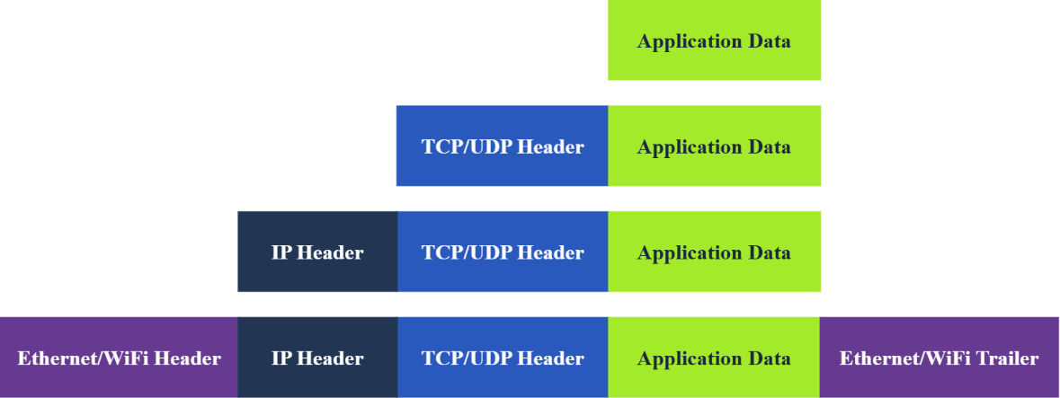
Browser
↓
HTTP Request
↓
TCP Segment
↓
IP Packet
↓
Ethernet/WiFi Frame
↓
Signals on Network
↓
Router
↓
Internet
↓
TryHackMe Server

Easy Real-World Analogy
Networking | Postal Service
HTTP Data | Letter
TCP | Tracking + guaranteed delivery
IP Address | House address
MAC Address | Local apartment/door identifier
Router | Post office
Internet | Road system

Key Concepts to Remember
Concept | Meaning
Encapsulation | Each layer adds its own header
TCP | Reliable communication
IP | Routing across networks
MAC | Local delivery
Router | Forwards packets
HTTPS | Encrypted communication

6. TELNET
6.1 Overview
- Remote terminal protocol.
- TCP port 23.
Uses
- Remote communication
- Manual protocol testing

6.2 Example Services
Service | Port
Echo | 7
Daytime | 13
HTTP | 80

6.3 Basic HTTP Request via Telnet
GET / HTTP/1.1
Host: example.com

7. DHCP
7.1 Purpose
- Automatically configures network settings.
Provides
- IP address
- Gateway
- DNS server
Ports
- Server: UDP 67
- Client: UDP 68

7.2 DORA Process
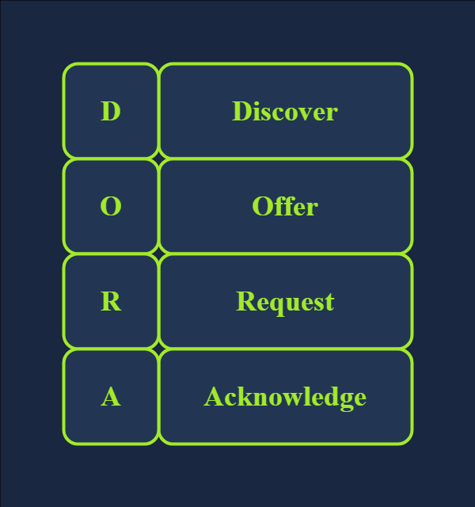
Step | Meaning
D | Discover
O | Offer
R | Request
A | Acknowledge

DHCP follows four steps: Discover, Offer, Request, and Acknowledge (DORA):
- DHCP Discover: The client broadcasts a DHCPDISCOVER message seeking the local DHCP server if one exists.
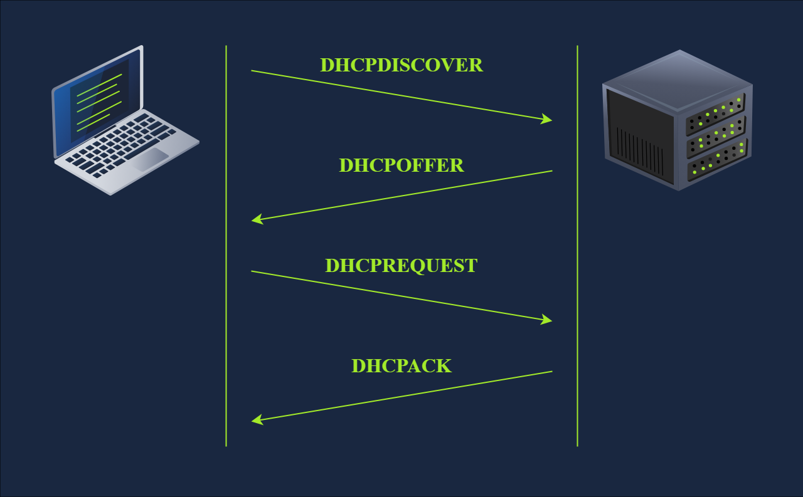
- DHCP Offer: The server responds with a DHCPOFFER message with an IP address available for the client to accept.
- DHCP Request: The client responds with a DHCPREQUEST message to indicate that it has accepted the offered IP.
- DHCP Acknowledge: The server responds with a DHCPACK message to confirm that the offered IP address is now assigned to this client.

8. ARP
8.1 Purpose
- Resolves IP address to MAC address.

8.2 ARP Process
Request
Who has 192.168.66.1?
Reply
192.168.66.1 is at 44:df:65:d8:fe:6c

9. ICMP
9.1 Purpose
- Diagnostics and error reporting.

9.2 Ping
- Uses ICMP Echo Request/Reply.
Command
ping 192.168.1.1

9.3 Traceroute
- Uses TTL values.
Commands
traceroute example.com
tracert example.com

10. NAT
10.1 Purpose
- Allows multiple private devices to share one public IP.
Benefits
- Conserves IPv4 addresses.

10.2 Translation Table
Maps:
- Internal IP + Port
- External IP + Port

11. DNS
11.1 Purpose
- Converts domain names to IP addresses.
Ports
- UDP 53
- TCP 53

11.2 DNS Records
Record | Purpose
A | IPv4 address
AAAA | IPv6 address
CNAME | Alias
MX | Mail server

11.3 DNS Lookup
nslookup example.com

12. WHOIS
12.1 Purpose
- Displays domain registration details.
Command
whois example.com

13. HTTP & HTTPS
13.1 HTTP Methods
Method | Purpose
GET | Retrieve data
POST | Submit data
PUT | Create/update
DELETE | Remove resource

13.2 Default Ports
Protocol | Port
HTTP | 80
HTTPS | 443

14. FTP
14.1 Purpose
- File transfer protocol.
Port
- TCP 21

14.2 FTP Commands
Command | Purpose
USER | Username
PASS | Password
RETR | Download
STOR | Upload

15. SMTP
15.1 Purpose
- Sends email.
Port
- TCP 25

15.2 SMTP Commands
Command | Purpose
HELO/EHLO | Start session
MAIL FROM | Sender
RCPT TO | Receiver
DATA | Email body

16. POP3
16.1 Purpose
- Retrieves emails.
Port
- TCP 110

16.2 POP3 Commands
Post Office Protocol Version 3 (POP3) is an alternative protocol for receiving emails that downloads emails from the server to a local device. Using POP3, a recipient cannot access their emails again from a different device because they are stored locally and then deleted from the email server.
Command | Purpose
USER | Username
PASS | Password
LIST | List emails
RETR | Retrieve email

17. IMAP
The Internet Message Access Protocol (IMAP) is a protocol for receiving email. Protocols standardize technical processes so computers and servers can connect with each other regardless of whether or not they use the same hardware or software.
17.1 Purpose
- Synchronizes email across devices.
Port
- TCP 143

17.2 IMAP Commands
Command | Purpose
LOGIN | Authenticate
SELECT | Open mailbox
FETCH | Retrieve email
LOGOUT | Exit

18. TLS / SSL
18.1 Purpose
- Secure communication.
Provides
- Confidentiality
- Integrity

18.2 Secure Protocols
Insecure | Secure
HTTP | HTTPS
SMTP | SMTPS
POP3 | POP3S
IMAP | IMAPS

18.3 Secure Ports
Protocol | Port
HTTPS | 443
SMTPS | 465/587
POP3S | 995
IMAPS | 993

19. SSH & SFTP
19.1 SSH
Features
- Secure remote access
- Encryption
- Tunneling
Port
- TCP 22
Command
ssh user@host

19.2 SFTP
Purpose
- Secure file transfer over SSH.
Commands
get filename
put filename

20. VPN
20.1 Purpose
- Secure private communication over Internet.
Benefits
- Encryption
- Remote access
- IP masking

21. Wireshark
21.1 Use Cases
- Troubleshooting
- Packet analysis
- Security investigation

21.2 Main Panes
Pane | Purpose
Packet List | Packet summary
Packet Details | Protocol breakdown
Packet Bytes | Hex/ASCII data

21.3 Useful Features
- Filters
- Follow stream
- Packet coloring
- Export packets
- Expert info

21.4 Common Display Filters
Protocol
http
arp
dns
Port
tcp.port == 80
IP
ip.addr == 192.168.1.1

22. Tcpdump
22.1 Basic Commands
Command | Purpose
-i | Interface
-w | Write pcap
-r | Read pcap
-c | Packet count
-n | No DNS resolve
-nn | No DNS/port resolve
-v | Verbose

22.2 Examples
Capture on interface
tcpdump -i eth0
Save packets
tcpdump -w file.pcap
Read packets
tcpdump -r file.pcap

22.3 Filtering
By Host
tcpdump host 1.1.1.1
By Port
tcpdump port 53
By Protocol
tcpdump icmp

22.4 Logical Operators
Operator | Meaning
and | Both true
or | Either true
not | Negation

22.5 Output Options
Option | Purpose
-q | Quick output
-e | Show MAC
-A | ASCII
-xx | Hex
-X | Hex + ASCII

23. Nmap
23.1 Purpose
- Host discovery
- Port scanning
- Service detection

23.2 Host Discovery
Ping Scan
nmap -sn 192.168.1.0/24
List Scan
nmap -sL 192.168.1.0/24

23.3 TCP Scans
Scan | Option
Connect | -sT
SYN | -sS

23.4 UDP Scan
nmap -sU

23.5 Port Selection
Option | Purpose
-F | Fast scan
-p | Specify ports
-p- | All ports

23.6 Service Detection
Option | Purpose
-O | OS detection
-sV | Version detection
-A | Aggressive scan
-Pn | Treat host as online

23.7 Timing
Timing | Meaning
T0 | Paranoid
T1 | Sneaky
T2 | Polite
T3 | Normal
T4 | Aggressive
T5 | Insane

23.8 Output Formats
Option | Format
-oN | Normal
-oX | XML
-oG | Grepable
-oA | All formats

